Winter Seminars!!

**Sparring Seminar:** Thursday 1/2/25

@ Pitman Dojo: 6pm- 7:30pm

(72 East Holly Ave., Pitman 08071)



**Takedown Seminar:** Friday 1/3/25

@ Mullica Hill Dojo: 6:45pm - 8:15pm

(33 South Main Street, Mullica Hill 08062)

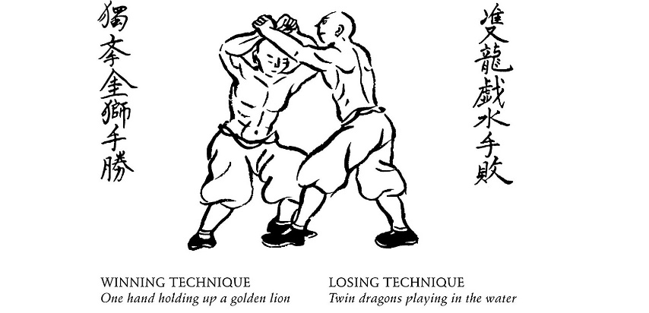

**Bunkai Seminar:** Saturday 1/4/25

@ Mullica Hill Dojo: 6pm – 7:30pm

(33 South Main Street, Mullica Hill 08062)

Scan the QR Code for eligibility, more info and to register by 1/1/25.