**Dojo Update 7/14/2025**

**What is the Board Breaking Challenge?** The Challenge is an excellent learning opportunity for students of all ranks (Dragons thru Black Belts) and all levels of board breaking experience. The first half of the seminar is instructional - students learn a variety of hand & foot breaks using re-breakable boards at first and then a portion of their own allotment of boards. In the second half, students challenge themselves with the boards they set aside for the "Challenge" portion.

**For more details,** please see the *What is the Board Breaking Challenge?* on the website & in the dojo, or speak to your child’s instructor.

**Registration forms** can be picked up in both Parent Galleries or printed from the website. Go to DOCS… scroll to Event Information & Forms… select Board Breaking Challenge Registration. **Form due by Wednesday, July 16.**

**Challenge Date:** Saturday, July 19

**Location:** our dojo

**Time:** 9 a.m. all ranks

**Dress Code:** Full Uniform; jacket, gi pants, karate t-shirt (red, yellow or black) & belt OR summer uniform; karate t-shirt (red, yellow or black) gi pants (white, black or leadership) & belt.

**Leadership Students:** bring shin guard, dominant hand & foot gear

**Non-Leadership:** Safety gear will be provided; see your instructor by Wednesday, July 16

***Bring a re-usable bag to carry out un-broken boards for future event & broken boards for fire pit/fireplace***

**This cycle’s Curriculum Note/Study Sheets** are available on the website. These sheets reinforce the material students are learning in class and helps prepare them for belt graduation, as well as their journey to Black Belt training.

Reach out to Sensei Fran if you need a hard copy. ([okkamullicahill@comcast.net](mailto:okkamullicahill@comcast.net)) .

**Best of Gloucester County Voting is OPEN**! We humbly ask for your vote for **Fun and Fit Aftercare** (for our aftercare and Summer Camp Program) **on line 6** – Daycare/Nursery and **OKKA-Mullica Hill** for the Karate Program **on line 80.** As both a local and family-owned business, we appreciate the support of our customers and your support for all Mullica Hill local business!

Copy the link [www.gcbestof.com](http://www.gcbestof.com/) or use the QR code below. If there are multiple family members in your home that have e-mail addresses but use the same computer, it’s best to use Incognito mode (or similar), as the website keeps cookies that show a vote was cast on the device. All individuals may vote; it is NOT one vote per household.

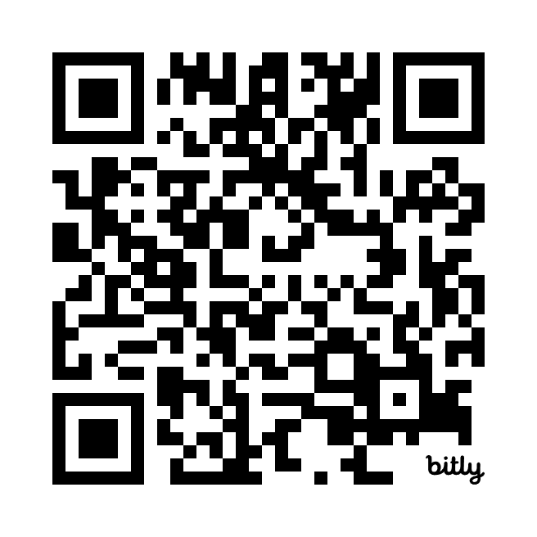

**Summer of Fun calendar CORRECTION… CHANGE 9/6 to 9/5… thanks Sammy Mazzeo! Good Catch!**

**This Week**

* 7/14 – 7/17: Week 4 of the cycle. Green Tip for Combo in 2nd class of the week.
* **Leadership** **Bring:** Intermed/Adv. = Nunchuks; Shodan/Nidan = Katana; Sandan.Yondan = Bo/Nunte Bo
* 7/15 (Tuesday) 7:30 p.m. Joint CIT reward activity @ MH dojo.
* 7/16 (Wednesday) Registration form for the Mini Board Breaking Challenge is DUE by Today.
* 7/17 (Thursday) **Karate Chop!** (learn how to break boards) ***Parents, siblings & friends welcome tonight.***
* 7/19 (Saturday) **Mini Board Breaking Challenge** at our dojo. See above for details.
* S.T.A.R. Theme for July is ***Be* *Courageous*** *(try new things/do things that are hard/stand up for others)*
* CIT: Please use SignUp Genius to schedule your assist classes.
* **Lost & Found**: Please check the Loft Gallery if/when your family is missing something.

**Coming Up...**

* 7/21 (Monday) **Water Gun Fun!** **Little Dragons @ 5:30pm;** **Basic - Black Belt @ 6:30pm.** Bring water guns & towels. Wear clothing that can get wet! ***This is a weather permitting activity.*** In the event of bad weather, our regularly scheduled classes will be held inside the dojo, minus the water guns. *Rain date 7/22.* **ONLY Parents &****Siblings are invited to participate in this activity.**
* 7/28 -7/31: **Dojo CLOSED for Vacation.**
* 8/4 (Monday) **Ninja NERF Wars**; bring a NERF gun to class (one that your child can operate easily). Eye protection required - swim goggles work well. ***Parents, siblings & friends welcome tonight.***
* 8/7 (Thursday) **Sign up for the Summer Party by today.**

**CURRENT Class Schedule: June 30 – August 28**

**Little Dragon** @ 4:30 p.m. & 5:15 p.m. Monday – Thursday

**Basic** @ 6 p.m. Monday - Thursday

**Intermed/Adv.** @ 6:45 p.m. Monday & Wednesday; @ 7:40 p.m. Tuesday & Thursday

**Black Belt** @ 7:40 p.m. Monday & Wednesday; @ 6:45 p.m. Tuesday & Thursday

Both the **July – December 2025 calendar** and the **Summer of Fun 2025 calendar** can be found at okkamullicahill.com (to view or print) and hard copies in both Parent Galleries.

**Attention ALL Ranks:**You can find instructional videos on our YouTube channel (OKKA Mullica Hill). The link is on our website in the DOCS tab. Please allow your child to watch our videos (especially if extra help is needed) so he/she can stay on track with this cycle's material.  Questions about the videos or how to use the YouTube channel are best directed to Sensei Aidan. (senseicoakley@gmail.com)

**Reminder for Leadership students (& parents)**: Students should be taking their gear bags and weapons home after class. It’s necessary for students to have their weapons at home in order to practice the techniques, as well as the actual weapon kata. Practicing for 10 to 15 minutes a day on non-class days, at least 3 days per week is the expectation. Doing so is how students develop the skills needed to excel with their weapons. ***Repetition is the motor of learning.***

**Fitness Star Reminder:** Sign up for your Fitness Star Evaluation **at least 1 day prior** to your requested day & time; Evaluations happen during Week 7: Monday through Thursday; Week 8: Monday Only. The sign-up sheet is on the credenza behind the Parent Gallery. All students (Basic – Black Belt) & parents are encouraged to participate.See Sensei Aidan if you have questions or see the website. Go to DOCS… scroll to Physical Fitness Star Program… select *click here*.

**In an effort to improve communication and provide alternative modes to get dojo info to you, we are increasing our social media footprint.** Please Like & Follow us on Facebook at OKKA – Mullica Hill. On Instagram, please Like & Follow OKKA_Mullica Hill.If you aren’t into social media, no worries, see the Dojo Update every Sunday on the website.

**In the event that we need to close the dojo due to inclement weather or an emergency situation…** notification will be posted on Facebook (OKKA – Mullica Hill). **Please like & follow us if you are a FB person.** If you are not a FB person, there will also be a message on the dojo phone (856-418-1592) by 3 p.m

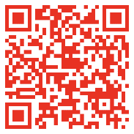**Scan this QR code** to go to the Documents page of our website for the Dojo Update, as well as important documents and forms.

**Contact Info**

Sensei Fran: 856-816-1538; [okkamullicahill@comcast.net](mailto:okkamullicahill@comcast.net) ; Sensei Aidan: 856-725-1414; [senseicoakley@gmail.com](mailto:senseicoakley@gmail.com)

Dojo phone: 856-418-1592

Facebook: OKKA – Mullica Hill; Instagram: OKKA_Mullica Hill